Energy Usage Analysis - Feature Engineering + Modelling + Insight Generation

2023-12-01

### Group : IST687 M004 Group 1

## Contents

### 1.Install Dependancies

### 2.Data Cleaning + Feature Engineering

### 3.Exploratory Data Analysis

### 4.Modelling

### 5.Insight Generation

### 6.Prediction - Future Energy Consumption

##—————————————————————————————————————————————————————–>

## 1.Load Required Dependancies

# Load required Libraries  
  
options(warn=-1)  
# install.packages("corrplot")  
# install.packages("catboost")  
# install.packages('devtools')  
# devtools::install_url('BINARY_URL'[, INSTALL_opts = c("--no-multiarch", "--no-test-load")])  
# devtools::install_url('https://github.com/catboost/catboost/releases/download/v1.2.2/catboost-R-Windows-1.2.2.tgz', INSTALL_opts = c("--no-multiarch", "--no-test-load"))  
# install.packages("xgboost")  
# install.packages("shapviz")  
library(arrow)

##   
## Attaching package: 'arrow'

## The following object is masked from 'package:utils':  
##   
## timestamp

library(tidyverse)

## ── Attaching core tidyverse packages ──────────────────────── tidyverse 2.0.0 ──  
## ✔ dplyr 1.1.2 ✔ readr 2.1.4  
## ✔ forcats 1.0.0 ✔ stringr 1.5.0  
## ✔ ggplot2 3.4.3 ✔ tibble 3.2.1  
## ✔ lubridate 1.9.2 ✔ tidyr 1.3.0  
## ✔ purrr 1.0.2

## ── Conflicts ────────────────────────────────────────── tidyverse_conflicts() ──  
## ✖ lubridate::duration() masks arrow::duration()  
## ✖ dplyr::filter() masks stats::filter()  
## ✖ dplyr::lag() masks stats::lag()  
## ℹ Use the conflicted package (<http://conflicted.r-lib.org/>) to force all conflicts to become errors

library(lobstr)  
library(imputeTS)

## Registered S3 method overwritten by 'quantmod':  
## method from  
## as.zoo.data.frame zoo

library(curl)

## Using libcurl 8.3.0 with Schannel  
##   
## Attaching package: 'curl'  
##   
## The following object is masked from 'package:readr':  
##   
## parse_date

library(httr)

##   
## Attaching package: 'httr'  
##   
## The following object is masked from 'package:curl':  
##   
## handle_reset

library(xml2)  
library(aws.s3)  
library(corrplot)

## corrplot 0.92 loaded

library(xgboost)

##   
## Attaching package: 'xgboost'  
##   
## The following object is masked from 'package:dplyr':  
##   
## slice

library(readr)  
library(stringr)  
library(dplyr)  
library(caret)

## Loading required package: lattice  
##   
## Attaching package: 'caret'  
##   
## The following object is masked from 'package:httr':  
##   
## progress  
##   
## The following object is masked from 'package:purrr':  
##   
## lift

library(car)

## Loading required package: carData  
##   
## Attaching package: 'car'  
##   
## The following object is masked from 'package:dplyr':  
##   
## recode  
##   
## The following object is masked from 'package:purrr':  
##   
## some

library(catboost)  
library(recipes)

##   
## Attaching package: 'recipes'  
##   
## The following object is masked from 'package:stringr':  
##   
## fixed  
##   
## The following object is masked from 'package:stats':  
##   
## step

library(ggplot2)  
library(shapviz)  
  
  
  
# library(knitr)  
# hook_output = knit_hooks$get('output')  
# knit_hooks$set(output = function(x, options) {  
# # this hook is used only when the linewidth option is not NULL  
# if (!is.null(n <- options$linewidth)) {  
# x = xfun::split_lines(x)  
# # any lines wider than n should be wrapped  
# if (any(nchar(x) > n)) x = strwrap(x, width = n)  
# x = paste(x, collapse = '\n')  
# }  
# hook_output(x, options)  
# })  
#   
# knitr::opts_chunk$set(tidy.opts = list(width.cutoff = 60), tidy = TRUE)

##—————————————————————————————————————————————————————–>

## 2.Data Cleaning + Feature Engineering

### 2.1. Load Dataset

static_house_energy_weather_df <- read_csv("C:/Users/Himanshu/OneDrive/Desktop/Syracuse Sem 1/IST-687 Intro to DS Lab/Final Project/static_house_energy_weather_df_17130_rows_with_time_of_day.csv",show_col_types = FALSE)

### 2.2. Study Unique Values in Dataset

# Unique Values  
unique_value_in_each_column <- lapply(static_house_energy_weather_df, unique)  
  
dim(static_house_energy_weather_df)

## [1] 17130 180

### 2.3.

### Removing columns based on info in metadata file and columns with only 1 value.

### Ordinal Encode Required Columns

### Remove Negative energy rows

#Define Required Columns  
  
cols_req <- c('bldg_id','in.county', 'in.sqft', 'in.bedrooms',  
'in.building_america_climate_zone', 'in.ceiling_fan', 'in.city', 'in.clothes_dryer', 'in.clothes_washer', 'in.cooking_range', 'in.cooling_setpoint', 'in.cooling_setpoint_has_offset', 'in.cooling_setpoint_offset_magnitude', 'in.cooling_setpoint_offset_period',   
'in.dishwasher', 'in.ducts',   
 'in.federal_poverty_level', 'in.geometry_attic_type', 'in.geometry_floor_area', 'in.geometry_floor_area_bin', 'in.geometry_foundation_type', 'in.geometry_garage', 'in.geometry_stories',  
 'in.geometry_wall_exterior_finish', 'in.geometry_wall_type', 'in.has_pv', 'in.heating_fuel', 'in.heating_setpoint', 'in.heating_setpoint_has_offset',  
'in.heating_setpoint_offset_magnitude', 'in.heating_setpoint_offset_period', 'in.hot_water_fixtures', 'in.hvac_cooling_efficiency', 'in.hvac_cooling_partial_space_conditioning',  
'in.hvac_cooling_type', 'in.hvac_has_ducts', 'in.hvac_has_zonal_electric_heating', 'in.hvac_heating_efficiency', 'in.hvac_heating_type', 'in.hvac_heating_type_and_fuel',  
 'in.income', 'in.infiltration', 'in.insulation_ceiling',   
'in.insulation_floor', 'in.insulation_foundation_wall', 'in.insulation_rim_joist', 'in.insulation_roof', 'in.insulation_slab', 'in.insulation_wall',   
'in.misc_extra_refrigerator', 'in.misc_freezer', 'in.misc_gas_fireplace',  
'in.misc_gas_grill', 'in.misc_gas_lighting', 'in.misc_hot_tub_spa', 'in.misc_pool', 'in.misc_pool_heater', 'in.misc_pool_pump', 'in.misc_well_pump', 'in.natural_ventilation', 'in.neighbors',  
'in.occupants', 'in.orientation', 'in.plug_load_diversity', 'in.pv_orientation', 'in.pv_system_size',   
'in.refrigerator', 'in.roof_material', 'in.tenure', 'in.units_represented', 'in.usage_level', 'in.vacancy_status', 'in.vintage', 'in.vintage_acs',  
'in.water_heater_efficiency', 'in.water_heater_fuel', 'in.window_areas',  
'in.windows', 'upgrade.insulation_roof', 'upgrade.water_heater_efficiency', 'upgrade.hvac_cooling_efficiency', 'upgrade.infiltration_reduction', 'upgrade.geometry_foundation_type',  
'upgrade.clothes_dryer', 'upgrade.insulation_ceiling', 'upgrade.ducts', 'upgrade.hvac_heating_type', 'upgrade.insulation_wall', 'upgrade.insulation_foundation_wall',  
'upgrade.hvac_heating_efficiency', 'upgrade.cooking_range', 'time_of_day', 'total_energy_consumption', 'dry_bulb_temperature_[°c]', 'relative_humidity_[%]', 'wind_speed_[m/s]', 'wind_direction_[deg]', 'global_horizontal_radiation_[w/m2]',  
 'direct_normal_radiation_[w/m2]', 'diffuse_horizontal_radiation_[w/m2]')  
  
static_house_energy_weather_df2 <- static_house_energy_weather_df %>% select(all_of(cols_req))  
  
# Convert 'None' to NA  
static_house_energy_weather_df2[static_house_energy_weather_df2 == 'None'] <- NA  
  
  
  
# Function to drop columns with only one unique value  
drop_single_unique_columns <- function(data) {  
 single_unique_cols <- sapply(data, function(col) length(unique(col)) == 1)  
 return(data[, !single_unique_cols, drop = FALSE])  
}  
  
# Use the function to drop columns  
static_house_energy_weather_df2 <- drop_single_unique_columns(static_house_energy_weather_df2)  
  
# Convert time of day and other column columns to numbers - Ordinal Encoding  
time_of_day_mapping <- c("morning"=1,"afternoon-evening"=2,"night"=3)  
in_vacancy_status_mapping <- c("Occupied"=1, "Vacant"=0 )  
in_geometry_floor_area_mapping <- c("0-499"=0 ,"500-749"=1,"750-999"=2,"1000-1499"=3,"1500-1999"=4,"2000-2499"=5,"2500-2999"=6,"3000-3999"=7,"4000+"=8)   
in_hot_water_fixtures_mapping <- c("100% Usage"=1, "50% Usage"=0, "200% Usage"=2)  
upgrade_cooking_range_mapping <- c("Electric, Induction, 100% Usage"=1, "Electric, Induction, 80% Usage"=0, "Electric, Induction, 120% Usage"=3)  
in_occupants_mapping <- c("1"=1 , "2"=2,"3"=3,"4"=4,"5"=5,"8"=8,"6"=6,"7"=7,"10+"=10,"9"=9)  
income_mapping <- c("<10000"=1, "10000-14999"=2, "15000-19999"=3, "20000-24999"=4, "25000-29999"=5, "30000-34999"=6, "35000-39999"=7, "40000-44999"=8, "45000-49999"=9, "50000-59999"=10, "60000-69999"=11, "70000-79999"=12, "80000-99999"=13, "100000-119999"=14, "120000-139999"=15, "140000-159999"=16, "160000-179999"=17, "180000-199999"=18, "200000+"=19)  
  
static_house_energy_weather_df2$time_of_day <- as.numeric(time_of_day_mapping[static_house_energy_weather_df2$time_of_day])  
static_house_energy_weather_df2$in.vacancy_status <- as.numeric(in_vacancy_status_mapping[static_house_energy_weather_df2$in.vacancy_status])  
static_house_energy_weather_df2$in.geometry_floor_area <- as.numeric(in_geometry_floor_area_mapping[static_house_energy_weather_df2$in.geometry_floor_area])  
static_house_energy_weather_df2$in.hot_water_fixtures <- as.numeric(in_hot_water_fixtures_mapping[static_house_energy_weather_df2$in.hot_water_fixtures])  
static_house_energy_weather_df2$upgrade.cooking_range <- as.numeric(upgrade_cooking_range_mapping[static_house_energy_weather_df2$upgrade.cooking_range])  
static_house_energy_weather_df2$in.occupants <- as.numeric(in_occupants_mapping[static_house_energy_weather_df2$in.occupants])  
str(static_house_energy_weather_df2$time_of_day)

## num [1:17130] 3 1 2 3 1 2 3 1 2 3 ...

static_house_energy_weather_df2$in.income <- as.numeric(income_mapping[static_house_energy_weather_df2$in.occupants])  
str(static_house_energy_weather_df2$in.income)

## num [1:17130] 3 3 3 1 1 1 2 2 2 2 ...

# Remove negative Target  
static_house_energy_weather_df2 <- static_house_energy_weather_df2 %>% filter(total_energy_consumption>=0)  
dim(static_house_energy_weather_df2)

## [1] 17085 96

###2.4. #### Calculate Percentage of nulls in each row - Remove those greater than 80%. #### Fill Categorical Nulls with mode at Country - Income Level. #### Remove any remaining Null rows, if any.

static_house_energy_weather_df3 <- static_house_energy_weather_df2  
  
# Function to calculate percentage of nulls in each column  
percentage_nulls <- function(column) {  
 sum(is.na(column)) / length(column) * 100  
}  
  
# Apply the function to each column  
column_null_percentage <- sapply(static_house_energy_weather_df3, percentage_nulls)  
  
# Extract columns with more than 80% nulls  
columns_above_threshold <- names(column_null_percentage[column_null_percentage < 80])  
  
# Extract only those columns from the original data frame  
static_house_energy_weather_df3 <- static_house_energy_weather_df3[, columns_above_threshold]  
  
# dim(static_house_energy_weather_df3)  
  
  
# Function to fill missing values with the mode within each group  
fill_mode <- function(x) {  
 if (is.character(x)) {  
 mode_table <- table(x)  
 if (length(mode_table) > 0) {  
 mode_val <- names(sort(mode_table, decreasing = TRUE))[1]  
 x[is.na(x)] <- mode_val  
 }  
 }  
 x  
}  
  
# Apply the fill_mode function to each character column within each group  
static_house_energy_weather_df3 <- static_house_energy_weather_df3 %>%  
 group_by(in.city,in.income) %>%  
 mutate(across(where(is.character), fill_mode))  
  
# Apply the fill_mode function again to those that do not have a mode inside a group  
static_house_energy_weather_df3 <- static_house_energy_weather_df3 %>%  
 mutate(across(where(is.character), fill_mode))  
  
  
  
# Drop NA Rows - 90% of rows remaining  
static_house_energy_weather_df3 <- na.omit(static_house_energy_weather_df3)  
dim(static_house_energy_weather_df3)

## [1] 16340 85

column_null_percentage <- sapply(static_house_energy_weather_df3, percentage_nulls)

##—————————————————————————————————————————————————————–>

### 3.3.Exploratory Data Analysis

#### 3.1.Distribution of Target Variable - Total Energy Consumption

#### -> It is observed that target variable is slightly right-skewed.

# Histogram plot  
hist(static_house_energy_weather_df3$total_energy_consumption, col='purple', border='black', breaks=50,  
 main='Total Energy Consumption Distribution', xlab='Total Energy Consumption', ylab='Frequency')

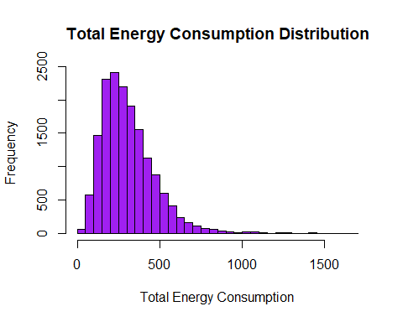

#### 3.2 Distribution of Continuous Independanct Features

# Histogram plot -> dry_bulb_temperature_  
hist(static_house_energy_weather_df3$`dry_bulb_temperature_[°c]`, col='purple', border='black', breaks=50,  
 main='Dry Bulb Temparature Distribution', xlab='Dry Bulb Temparature', ylab='Frequency')

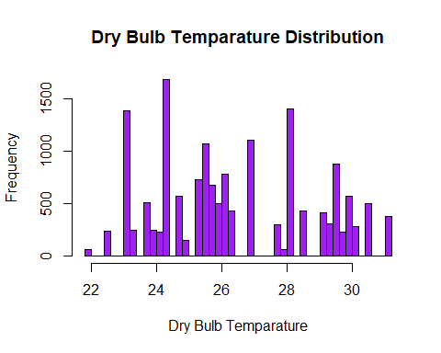

# Histogram plot -> global_horizontal_radiation_  
hist(static_house_energy_weather_df3$`global_horizontal_radiation_[w/m2]`, col='purple', border='black', breaks=50,  
 main='Global Horizontal Radiation Distribution', xlab='Global Horizontal Radiation', ylab='Frequency')

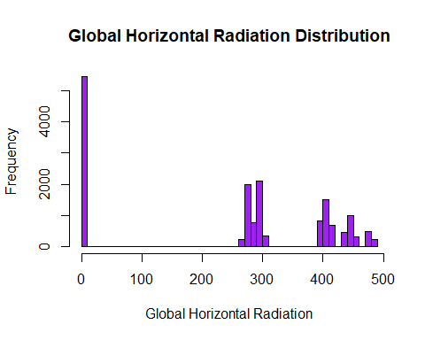

# Histogram plot -> in.sqft  
hist(static_house_energy_weather_df3$in.sqft, col='purple', border='black', breaks=50,  
 main='Size of House Distribution', xlab='Size of House', ylab='Frequency')

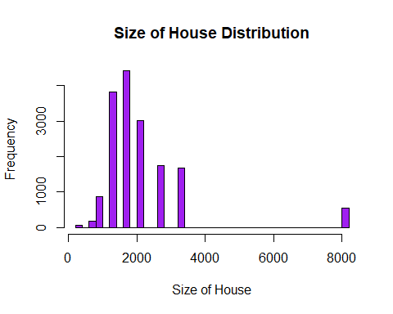

# Histogram plot -> Income  
hist(static_house_energy_weather_df3$in.income, col='purple', border='black', breaks=50,  
 main='Income Distribution', xlab='Income', ylab='Frequency')

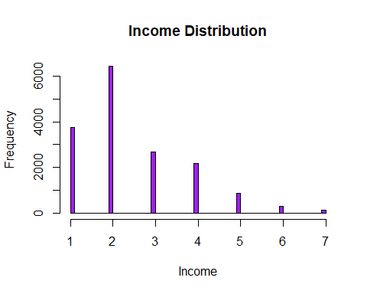

# Histogram plot -> Colling Setpoint  
hist(static_house_energy_weather_df3$in.cooling_setpoint, col='purple', border='black', breaks=50,  
 main='Cooling Setpoint Distribution', xlab='Cooling Setpoint', ylab='Frequency')

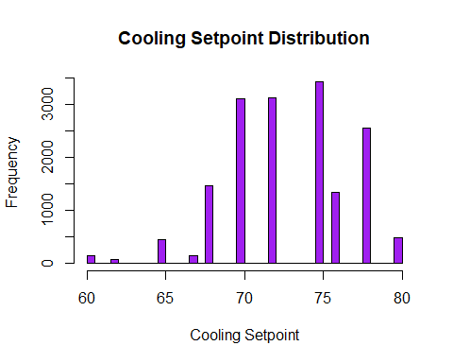

# Histogram plot -> Colling Setpoint  
hist(static_house_energy_weather_df3$in.hot_water_fixtures, col='purple', border='black', breaks=50,  
 main='Hot Water Fixtures Distribution', xlab='Hot Water Fixtures Setpoint', ylab='Frequency')

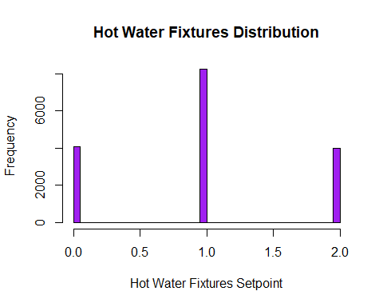

#### 3.3. Study Correlation between Continuous Features

#### Raditation and Humidity and Highly Negatively Correlated

#### Wind Speed and Radiation have a High Positive Correlation

# Select only the numerical variables from the dataset  
numerical_vars <- static_house_energy_weather_df3[sapply(static_house_energy_weather_df3, is.numeric)]  
  
# Calculate the correlation matrix  
cor_matrix <- cor(numerical_vars)  
# Set a threshold for correlation values  
threshold <- 0.4  
  
# Filter correlation matrix for values above the threshold  
filtered_cor_matrix <- cor_matrix * (abs(cor_matrix) > threshold)  
  
corrplot(filtered_cor_matrix, method = "number", type = "upper", tl.col = "black", tl.srt = 45, tl.cex = 0.6, number.cex = 0.6,title = "Correlation Plot",number.digits = 2)

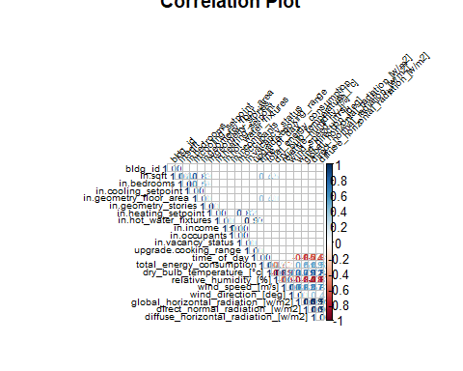

par(mfrow = c(1, 1), mar = c(1,1,1,1) + 5)

##—————————————————————————————————————————————————————–>

### 4. Modelling

#### Linear,Xgboost and Catboost were the three models that were used.

#### XGBoost and Catboost gave thebest accuracy with a MAPE of 17% (83% accruracy).

#### 4.1.Run Linear Regression - Run Linear Regression algorithm on Dataset

# Drop a few columns based on correlation  
static_house_energy_weather_df4 <- static_house_energy_weather_df3  
  
static_house_energy_weather_df4 <- static_house_energy_weather_df4 %>%  
 select(where(~n_distinct(.) > 1))  
  
  
# Create dataset with just building_id and county - To be used in prediction section  
static_house_energy_weather_df_for_prediction <- static_house_energy_weather_df4   
static_house_energy_weather_df_building_and_county <- static_house_energy_weather_df4[,c('bldg_id','in.county','time_of_day')]  
static_house_energy_weather_df4 <- static_house_energy_weather_df4 %>% select(-c( 'bldg_id','in.county','global_horizontal_radiation_[w/m2]',  
 'direct_normal_radiation_[w/m2]'))  
  
# lapply(static_house_energy_weather_df4, unique)  
  
rm(static_house_energy_weather_df)  
rm(static_house_energy_weather_df2)  
  
set.seed(123)  
  
# Split the data into training (80%) and testing (20%) sets  
index <- createDataPartition(static_house_energy_weather_df4$total_energy_consumption, p = 0.8, list = FALSE)  
train_data <- static_house_energy_weather_df4[index, ]  
test_data <- static_house_energy_weather_df4[-index, ]  
  
# Get character columns  
character_columns <- names(train_data)[sapply(train_data, is.character)]  
  
# Loop through character columns and apply the steps  
for (col in character_columns) {  
 # Get unique values in the current column  
  
 unique_values <- unique(train_data[[col]])  
  
 # Filter rows in other columns based on unique values  
 test_data <- test_data[test_data[[col]] %in% unique_values, ]  
}  
  
  
# Run linear regression with both categorical and continuous columns  
model <- lm(total_energy_consumption ~ ., data = train_data)  
  
# Print the summary of the model  
# summary(model)  
  
# Make predictions on the test data  
predictions <- predict(model, newdata = test_data)  
# test_data$predictions <- predictions  
# Evaluate the model on the test data (e.g., calculate RMSE)  
rmse <- sqrt(mean((test_data$total_energy_consumption - predictions)^2))  
print(paste("Root Mean Squared Error on test data:", rmse))

## [1] "Root Mean Squared Error on test data: 83.3659103617599"

cat("Minimum:", min(test_data$total_energy_consumption), "\n")

## Minimum: 3.707

cat("Maximum:", max(test_data$total_energy_consumption), "\n")

## Maximum: 1670.53

cat("Mean:", mean(test_data$total_energy_consumption), "\n")

## Mean: 310.9359

# Calculate MAPE  
mape <- mean(abs((test_data$total_energy_consumption - predictions) / test_data$total_energy_consumption )) * 100  
  
# Print the result  
print(paste("MAPE:", mape))

## [1] "MAPE: 25.8964937733538"

#R2  
r_squared <- R2(predictions, test_data$total_energy_consumption)  
print(paste("R-squared Linear Regression:", r_squared))

## [1] "R-squared Linear Regression: 0.756463521318137"

#### 4.2. Run CatBoost - Catboost is a Boosting Regression Model,

#### which specializes in handling categorical variables - which we have a lot of.

#### Boosting models are good at handling overfitting and non-linear data as they as equipped with

#### regularization parameters and do not require prior coolumn scaling.

# Create Train-Test Split  
train_data_ctb <- train_data  
test_data_ctb <- test_data  
# # Convert all character columns to factors - Need for Catboost  
# train_data_ctb[sapply(train_data_ctb, is.character)] <- lapply(train_data_ctb[sapply(train_data_ctb, is.character)],   
# as.factor)  
# test_data_ctb[sapply(test_data_ctb, is.character)] <- lapply(test_data_ctb[sapply(test_data_ctb, is.character)],   
# as.factor)  
  
# Identify character columns  
char_columns <- names(train_data_ctb)[sapply(train_data_ctb, is.character)]  
  
# Create a recipe for label encoding  
label_recipe <- recipe(~ ., data = train_data_ctb) %>%  
 step_dummy(all_nominal_predictors(), one_hot = FALSE)  
  
# Apply the label encoding recipe to the data  
train_data_ctb <- prep(label_recipe) %>% bake(new_data = train_data_ctb)

## New names:  
## New names:  
## New names:  
## New names:  
## • `in.cooling_setpoint_offset_period_Day.and.Night.Setup..1h` ->  
## `in.cooling_setpoint_offset_period_Day.and.Night.Setup..1h...116`  
## • `in.cooling_setpoint_offset_period_Day.and.Night.Setup..2h` ->  
## `in.cooling_setpoint_offset_period_Day.and.Night.Setup..2h...117`  
## • `in.cooling_setpoint_offset_period_Day.and.Night.Setup..3h` ->  
## `in.cooling_setpoint_offset_period_Day.and.Night.Setup..3h...118`  
## • `in.cooling_setpoint_offset_period_Day.and.Night.Setup..4h` ->  
## `in.cooling_setpoint_offset_period_Day.and.Night.Setup..4h...119`  
## • `in.cooling_setpoint_offset_period_Day.and.Night.Setup..5h` ->  
## `in.cooling_setpoint_offset_period_Day.and.Night.Setup..5h...120`  
## • `in.cooling_setpoint_offset_period_Day.and.Night.Setup..1h` ->  
## `in.cooling_setpoint_offset_period_Day.and.Night.Setup..1h...121`  
## • `in.cooling_setpoint_offset_period_Day.and.Night.Setup..2h` ->  
## `in.cooling_setpoint_offset_period_Day.and.Night.Setup..2h...122`  
## • `in.cooling_setpoint_offset_period_Day.and.Night.Setup..3h` ->  
## `in.cooling_setpoint_offset_period_Day.and.Night.Setup..3h...123`  
## • `in.cooling_setpoint_offset_period_Day.and.Night.Setup..4h` ->  
## `in.cooling_setpoint_offset_period_Day.and.Night.Setup..4h...124`  
## • `in.cooling_setpoint_offset_period_Day.and.Night.Setup..5h` ->  
## `in.cooling_setpoint_offset_period_Day.and.Night.Setup..5h...125`  
## • `in.cooling_setpoint_offset_period_Day.Setup..1h` ->  
## `in.cooling_setpoint_offset_period_Day.Setup..1h...127`  
## • `in.cooling_setpoint_offset_period_Day.Setup..2h` ->  
## `in.cooling_setpoint_offset_period_Day.Setup..2h...128`  
## • `in.cooling_setpoint_offset_period_Day.Setup..3h` ->  
## `in.cooling_setpoint_offset_period_Day.Setup..3h...129`  
## • `in.cooling_setpoint_offset_period_Day.Setup..4h` ->  
## `in.cooling_setpoint_offset_period_Day.Setup..4h...130`  
## • `in.cooling_setpoint_offset_period_Day.Setup..5h` ->  
## `in.cooling_setpoint_offset_period_Day.Setup..5h...131`  
## • `in.cooling_setpoint_offset_period_Day.Setup..1h` ->  
## `in.cooling_setpoint_offset_period_Day.Setup..1h...132`  
## • `in.cooling_setpoint_offset_period_Day.Setup..2h` ->  
## `in.cooling_setpoint_offset_period_Day.Setup..2h...133`  
## • `in.cooling_setpoint_offset_period_Day.Setup..3h` ->  
## `in.cooling_setpoint_offset_period_Day.Setup..3h...134`  
## • `in.cooling_setpoint_offset_period_Day.Setup..4h` ->  
## `in.cooling_setpoint_offset_period_Day.Setup..4h...135`  
## • `in.cooling_setpoint_offset_period_Day.Setup..5h` ->  
## `in.cooling_setpoint_offset_period_Day.Setup..5h...136`  
## • `in.cooling_setpoint_offset_period_Day.Setup.and.Night.Setback..1h` ->  
## `in.cooling_setpoint_offset_period_Day.Setup.and.Night.Setback..1h...138`  
## • `in.cooling_setpoint_offset_period_Day.Setup.and.Night.Setback..2h` ->  
## `in.cooling_setpoint_offset_period_Day.Setup.and.Night.Setback..2h...139`  
## • `in.cooling_setpoint_offset_period_Day.Setup.and.Night.Setback..3h` ->  
## `in.cooling_setpoint_offset_period_Day.Setup.and.Night.Setback..3h...140`  
## • `in.cooling_setpoint_offset_period_Day.Setup.and.Night.Setback..4h` ->  
## `in.cooling_setpoint_offset_period_Day.Setup.and.Night.Setback..4h...141`  
## • `in.cooling_setpoint_offset_period_Day.Setup.and.Night.Setback..5h` ->  
## `in.cooling_setpoint_offset_period_Day.Setup.and.Night.Setback..5h...142`  
## • `in.cooling_setpoint_offset_period_Day.Setup.and.Night.Setback..1h` ->  
## `in.cooling_setpoint_offset_period_Day.Setup.and.Night.Setback..1h...143`  
## • `in.cooling_setpoint_offset_period_Day.Setup.and.Night.Setback..2h` ->  
## `in.cooling_setpoint_offset_period_Day.Setup.and.Night.Setback..2h...144`  
## • `in.cooling_setpoint_offset_period_Day.Setup.and.Night.Setback..3h` ->  
## `in.cooling_setpoint_offset_period_Day.Setup.and.Night.Setback..3h...145`  
## • `in.cooling_setpoint_offset_period_Day.Setup.and.Night.Setback..4h` ->  
## `in.cooling_setpoint_offset_period_Day.Setup.and.Night.Setback..4h...146`  
## • `in.cooling_setpoint_offset_period_Day.Setup.and.Night.Setback..5h` ->  
## `in.cooling_setpoint_offset_period_Day.Setup.and.Night.Setback..5h...147`  
## • `in.cooling_setpoint_offset_period_Night.Setback..1h` ->  
## `in.cooling_setpoint_offset_period_Night.Setback..1h...149`  
## • `in.cooling_setpoint_offset_period_Night.Setback..2h` ->  
## `in.cooling_setpoint_offset_period_Night.Setback..2h...150`  
## • `in.cooling_setpoint_offset_period_Night.Setback..3h` ->  
## `in.cooling_setpoint_offset_period_Night.Setback..3h...151`  
## • `in.cooling_setpoint_offset_period_Night.Setback..4h` ->  
## `in.cooling_setpoint_offset_period_Night.Setback..4h...152`  
## • `in.cooling_setpoint_offset_period_Night.Setback..5h` ->  
## `in.cooling_setpoint_offset_period_Night.Setback..5h...153`  
## • `in.cooling_setpoint_offset_period_Night.Setback..1h` ->  
## `in.cooling_setpoint_offset_period_Night.Setback..1h...154`  
## • `in.cooling_setpoint_offset_period_Night.Setback..2h` ->  
## `in.cooling_setpoint_offset_period_Night.Setback..2h...155`  
## • `in.cooling_setpoint_offset_period_Night.Setback..3h` ->  
## `in.cooling_setpoint_offset_period_Night.Setback..3h...156`  
## • `in.cooling_setpoint_offset_period_Night.Setback..4h` ->  
## `in.cooling_setpoint_offset_period_Night.Setback..4h...157`  
## • `in.cooling_setpoint_offset_period_Night.Setback..5h` ->  
## `in.cooling_setpoint_offset_period_Night.Setback..5h...158`  
## • `in.cooling_setpoint_offset_period_Night.Setup..1h` ->  
## `in.cooling_setpoint_offset_period_Night.Setup..1h...160`  
## • `in.cooling_setpoint_offset_period_Night.Setup..2h` ->  
## `in.cooling_setpoint_offset_period_Night.Setup..2h...161`  
## • `in.cooling_setpoint_offset_period_Night.Setup..3h` ->  
## `in.cooling_setpoint_offset_period_Night.Setup..3h...162`  
## • `in.cooling_setpoint_offset_period_Night.Setup..4h` ->  
## `in.cooling_setpoint_offset_period_Night.Setup..4h...163`  
## • `in.cooling_setpoint_offset_period_Night.Setup..5h` ->  
## `in.cooling_setpoint_offset_period_Night.Setup..5h...164`  
## • `in.cooling_setpoint_offset_period_Night.Setup..1h` ->  
## `in.cooling_setpoint_offset_period_Night.Setup..1h...165`  
## • `in.cooling_setpoint_offset_period_Night.Setup..2h` ->  
## `in.cooling_setpoint_offset_period_Night.Setup..2h...166`  
## • `in.cooling_setpoint_offset_period_Night.Setup..3h` ->  
## `in.cooling_setpoint_offset_period_Night.Setup..3h...167`  
## • `in.cooling_setpoint_offset_period_Night.Setup..4h` ->  
## `in.cooling_setpoint_offset_period_Night.Setup..4h...168`  
## • `in.cooling_setpoint_offset_period_Night.Setup..5h` ->  
## `in.cooling_setpoint_offset_period_Night.Setup..5h...169`

# Apply the saved encoding recipe to the new data  
test_data_ctb <-prep(label_recipe) %>% bake(new_data = test_data_ctb)

## New names:  
## New names:  
## New names:  
## New names:  
## • `in.cooling_setpoint_offset_period_Day.and.Night.Setup..1h` ->  
## `in.cooling_setpoint_offset_period_Day.and.Night.Setup..1h...116`  
## • `in.cooling_setpoint_offset_period_Day.and.Night.Setup..2h` ->  
## `in.cooling_setpoint_offset_period_Day.and.Night.Setup..2h...117`  
## • `in.cooling_setpoint_offset_period_Day.and.Night.Setup..3h` ->  
## `in.cooling_setpoint_offset_period_Day.and.Night.Setup..3h...118`  
## • `in.cooling_setpoint_offset_period_Day.and.Night.Setup..4h` ->  
## `in.cooling_setpoint_offset_period_Day.and.Night.Setup..4h...119`  
## • `in.cooling_setpoint_offset_period_Day.and.Night.Setup..5h` ->  
## `in.cooling_setpoint_offset_period_Day.and.Night.Setup..5h...120`  
## • `in.cooling_setpoint_offset_period_Day.and.Night.Setup..1h` ->  
## `in.cooling_setpoint_offset_period_Day.and.Night.Setup..1h...121`  
## • `in.cooling_setpoint_offset_period_Day.and.Night.Setup..2h` ->  
## `in.cooling_setpoint_offset_period_Day.and.Night.Setup..2h...122`  
## • `in.cooling_setpoint_offset_period_Day.and.Night.Setup..3h` ->  
## `in.cooling_setpoint_offset_period_Day.and.Night.Setup..3h...123`  
## • `in.cooling_setpoint_offset_period_Day.and.Night.Setup..4h` ->  
## `in.cooling_setpoint_offset_period_Day.and.Night.Setup..4h...124`  
## • `in.cooling_setpoint_offset_period_Day.and.Night.Setup..5h` ->  
## `in.cooling_setpoint_offset_period_Day.and.Night.Setup..5h...125`  
## • `in.cooling_setpoint_offset_period_Day.Setup..1h` ->  
## `in.cooling_setpoint_offset_period_Day.Setup..1h...127`  
## • `in.cooling_setpoint_offset_period_Day.Setup..2h` ->  
## `in.cooling_setpoint_offset_period_Day.Setup..2h...128`  
## • `in.cooling_setpoint_offset_period_Day.Setup..3h` ->  
## `in.cooling_setpoint_offset_period_Day.Setup..3h...129`  
## • `in.cooling_setpoint_offset_period_Day.Setup..4h` ->  
## `in.cooling_setpoint_offset_period_Day.Setup..4h...130`  
## • `in.cooling_setpoint_offset_period_Day.Setup..5h` ->  
## `in.cooling_setpoint_offset_period_Day.Setup..5h...131`  
## • `in.cooling_setpoint_offset_period_Day.Setup..1h` ->  
## `in.cooling_setpoint_offset_period_Day.Setup..1h...132`  
## • `in.cooling_setpoint_offset_period_Day.Setup..2h` ->  
## `in.cooling_setpoint_offset_period_Day.Setup..2h...133`  
## • `in.cooling_setpoint_offset_period_Day.Setup..3h` ->  
## `in.cooling_setpoint_offset_period_Day.Setup..3h...134`  
## • `in.cooling_setpoint_offset_period_Day.Setup..4h` ->  
## `in.cooling_setpoint_offset_period_Day.Setup..4h...135`  
## • `in.cooling_setpoint_offset_period_Day.Setup..5h` ->  
## `in.cooling_setpoint_offset_period_Day.Setup..5h...136`  
## • `in.cooling_setpoint_offset_period_Day.Setup.and.Night.Setback..1h` ->  
## `in.cooling_setpoint_offset_period_Day.Setup.and.Night.Setback..1h...138`  
## • `in.cooling_setpoint_offset_period_Day.Setup.and.Night.Setback..2h` ->  
## `in.cooling_setpoint_offset_period_Day.Setup.and.Night.Setback..2h...139`  
## • `in.cooling_setpoint_offset_period_Day.Setup.and.Night.Setback..3h` ->  
## `in.cooling_setpoint_offset_period_Day.Setup.and.Night.Setback..3h...140`  
## • `in.cooling_setpoint_offset_period_Day.Setup.and.Night.Setback..4h` ->  
## `in.cooling_setpoint_offset_period_Day.Setup.and.Night.Setback..4h...141`  
## • `in.cooling_setpoint_offset_period_Day.Setup.and.Night.Setback..5h` ->  
## `in.cooling_setpoint_offset_period_Day.Setup.and.Night.Setback..5h...142`  
## • `in.cooling_setpoint_offset_period_Day.Setup.and.Night.Setback..1h` ->  
## `in.cooling_setpoint_offset_period_Day.Setup.and.Night.Setback..1h...143`  
## • `in.cooling_setpoint_offset_period_Day.Setup.and.Night.Setback..2h` ->  
## `in.cooling_setpoint_offset_period_Day.Setup.and.Night.Setback..2h...144`  
## • `in.cooling_setpoint_offset_period_Day.Setup.and.Night.Setback..3h` ->  
## `in.cooling_setpoint_offset_period_Day.Setup.and.Night.Setback..3h...145`  
## • `in.cooling_setpoint_offset_period_Day.Setup.and.Night.Setback..4h` ->  
## `in.cooling_setpoint_offset_period_Day.Setup.and.Night.Setback..4h...146`  
## • `in.cooling_setpoint_offset_period_Day.Setup.and.Night.Setback..5h` ->  
## `in.cooling_setpoint_offset_period_Day.Setup.and.Night.Setback..5h...147`  
## • `in.cooling_setpoint_offset_period_Night.Setback..1h` ->  
## `in.cooling_setpoint_offset_period_Night.Setback..1h...149`  
## • `in.cooling_setpoint_offset_period_Night.Setback..2h` ->  
## `in.cooling_setpoint_offset_period_Night.Setback..2h...150`  
## • `in.cooling_setpoint_offset_period_Night.Setback..3h` ->  
## `in.cooling_setpoint_offset_period_Night.Setback..3h...151`  
## • `in.cooling_setpoint_offset_period_Night.Setback..4h` ->  
## `in.cooling_setpoint_offset_period_Night.Setback..4h...152`  
## • `in.cooling_setpoint_offset_period_Night.Setback..5h` ->  
## `in.cooling_setpoint_offset_period_Night.Setback..5h...153`  
## • `in.cooling_setpoint_offset_period_Night.Setback..1h` ->  
## `in.cooling_setpoint_offset_period_Night.Setback..1h...154`  
## • `in.cooling_setpoint_offset_period_Night.Setback..2h` ->  
## `in.cooling_setpoint_offset_period_Night.Setback..2h...155`  
## • `in.cooling_setpoint_offset_period_Night.Setback..3h` ->  
## `in.cooling_setpoint_offset_period_Night.Setback..3h...156`  
## • `in.cooling_setpoint_offset_period_Night.Setback..4h` ->  
## `in.cooling_setpoint_offset_period_Night.Setback..4h...157`  
## • `in.cooling_setpoint_offset_period_Night.Setback..5h` ->  
## `in.cooling_setpoint_offset_period_Night.Setback..5h...158`  
## • `in.cooling_setpoint_offset_period_Night.Setup..1h` ->  
## `in.cooling_setpoint_offset_period_Night.Setup..1h...160`  
## • `in.cooling_setpoint_offset_period_Night.Setup..2h` ->  
## `in.cooling_setpoint_offset_period_Night.Setup..2h...161`  
## • `in.cooling_setpoint_offset_period_Night.Setup..3h` ->  
## `in.cooling_setpoint_offset_period_Night.Setup..3h...162`  
## • `in.cooling_setpoint_offset_period_Night.Setup..4h` ->  
## `in.cooling_setpoint_offset_period_Night.Setup..4h...163`  
## • `in.cooling_setpoint_offset_period_Night.Setup..5h` ->  
## `in.cooling_setpoint_offset_period_Night.Setup..5h...164`  
## • `in.cooling_setpoint_offset_period_Night.Setup..1h` ->  
## `in.cooling_setpoint_offset_period_Night.Setup..1h...165`  
## • `in.cooling_setpoint_offset_period_Night.Setup..2h` ->  
## `in.cooling_setpoint_offset_period_Night.Setup..2h...166`  
## • `in.cooling_setpoint_offset_period_Night.Setup..3h` ->  
## `in.cooling_setpoint_offset_period_Night.Setup..3h...167`  
## • `in.cooling_setpoint_offset_period_Night.Setup..4h` ->  
## `in.cooling_setpoint_offset_period_Night.Setup..4h...168`  
## • `in.cooling_setpoint_offset_period_Night.Setup..5h` ->  
## `in.cooling_setpoint_offset_period_Night.Setup..5h...169`

# Specify the columns for features and the response variable  
response <- "total_energy_consumption"  
  
# Select all columns except the excluded one  
selected_columns <- train_data_ctb[, !colnames(train_data_ctb) %in% response]  
  
# Convert the selected columns to a vector  
features <- colnames(selected_columns)  
  
# Convert response variable to numeric (CatBoost requires numeric target)  
train_data_ctb[[response]] <- as.numeric(train_data_ctb[[response]])  
  
# Convert the data to the CatBoost dataset format  
train_data_ctb2 <- catboost.load_pool(data = train_data_ctb[features], label = train_data_ctb[[response]])  
  
# Specify CatBoost parameters  
catboost_params <- list(  
 iterations = 100, # Number of boosting iterations  
 learning_rate = 0.1, # Learning rate  
 depth = 6, # Depth of the trees  
 loss_function = "RMSE", # Loss function for regression  
 logging_level = 'Silent'  
)  
  
# Train the CatBoost model  
# model <- catboost.train(train_data_ctb2, params = catboost_params)  
model <- catboost.train(train_data_ctb2,NULL, params = catboost_params)  
  
  
#Test Data  
new_data_pool <- catboost.load_pool(data = test_data_ctb)  
predictions_ctb <- catboost.predict(model, new_data_pool)  
  
  
#Catboost  
rmse <- sqrt(mean((test_data_ctb$total_energy_consumption - predictions_ctb)^2))  
print(paste("Root Mean Squared Error on test data:", rmse))

## [1] "Root Mean Squared Error on test data: 70.1861792978264"

cat("Minimum:", min(test_data_ctb$total_energy_consumption), "\n")

## Minimum: 3.707

cat("Maximum:", max(test_data_ctb$total_energy_consumption), "\n")

## Maximum: 1670.53

cat("Mean:", mean(test_data_ctb$total_energy_consumption), "\n")

## Mean: 310.9359

# Calculate MAPE  
mape <- mean(abs((test_data_ctb$total_energy_consumption - predictions_ctb) / test_data_ctb$total_energy_consumption )) * 100  
  
# Print the result  
print(paste("MAPE:", mape))

## [1] "MAPE: 18.9428563237314"

#R2  
r_squared <- R2(predictions_ctb, test_data_ctb$total_energy_consumption)  
print(paste("R-squared CTB:", r_squared))

## [1] "R-squared CTB: 0.829868885578707"

ctb_feature_imp_matrix <- catboost.get_feature_importance(model,  
 pool = NULL,  
 type = 'FeatureImportance',  
 thread_count = -1)  
  
# convert the matrix into dataframe   
dataframe_ctb_feature_imp=as.data.frame(ctb_feature_imp_matrix)  
colnames(dataframe_ctb_feature_imp) <- c("Feature_Importance")  
dataframe_ctb_feature_imp <- arrange(dataframe_ctb_feature_imp, desc(Feature_Importance))  
  
# Top Features from Catboost  
head(dataframe_ctb_feature_imp)

## Feature_Importance  
## dry_bulb_temperature_[°c] 18.895609  
## in.sqft 12.038119  
## time_of_day 9.316663  
## in.heating_setpoint 9.055751  
## in.geometry_floor_area 8.063708  
## in.vacancy_status 6.898157

#### 4.3, Run XGboost : Extreme Gradient Boosting model that is great at handling non-linear data.

#### Boosting models are good at handling overfitting and non-linear data as they as equipped with

#### regularization parameters and do not require prior coolumn scaling.

# https://tilburgsciencehub.com/building-blocks/analyze-data/machine-learning/xgboost/  
  
#Use train-test split created before  
train_data_xgb <- train_data  
test_data_xgb <- test_data  
# Convert all character columns to factors   
# train_data_xgb[sapply(train_data_xgb, is.character)] <- lapply(train_data_xgb[sapply(train_data_xgb, is.character)],   
# as.factor)  
# test_data_xgb[sapply(test_data_xgb, is.character)] <- lapply(test_data_xgb[sapply(test_data_xgb, is.character)],   
# as.factor)  
  
# Identify character columns  
char_columns <- names(train_data_xgb)[sapply(train_data_xgb, is.character)]  
  
# Create a recipe for label encoding  
label_recipe <- recipe(~ ., data = train_data_xgb) %>%  
 step_dummy(all_nominal_predictors(), one_hot = FALSE)  
  
# Apply the label encoding recipe to the data  
train_data_xgb <- prep(label_recipe) %>% bake(new_data = train_data_xgb)

## New names:  
## New names:  
## New names:  
## New names:  
## • `in.cooling_setpoint_offset_period_Day.and.Night.Setup..1h` ->  
## `in.cooling_setpoint_offset_period_Day.and.Night.Setup..1h...116`  
## • `in.cooling_setpoint_offset_period_Day.and.Night.Setup..2h` ->  
## `in.cooling_setpoint_offset_period_Day.and.Night.Setup..2h...117`  
## • `in.cooling_setpoint_offset_period_Day.and.Night.Setup..3h` ->  
## `in.cooling_setpoint_offset_period_Day.and.Night.Setup..3h...118`  
## • `in.cooling_setpoint_offset_period_Day.and.Night.Setup..4h` ->  
## `in.cooling_setpoint_offset_period_Day.and.Night.Setup..4h...119`  
## • `in.cooling_setpoint_offset_period_Day.and.Night.Setup..5h` ->  
## `in.cooling_setpoint_offset_period_Day.and.Night.Setup..5h...120`  
## • `in.cooling_setpoint_offset_period_Day.and.Night.Setup..1h` ->  
## `in.cooling_setpoint_offset_period_Day.and.Night.Setup..1h...121`  
## • `in.cooling_setpoint_offset_period_Day.and.Night.Setup..2h` ->  
## `in.cooling_setpoint_offset_period_Day.and.Night.Setup..2h...122`  
## • `in.cooling_setpoint_offset_period_Day.and.Night.Setup..3h` ->  
## `in.cooling_setpoint_offset_period_Day.and.Night.Setup..3h...123`  
## • `in.cooling_setpoint_offset_period_Day.and.Night.Setup..4h` ->  
## `in.cooling_setpoint_offset_period_Day.and.Night.Setup..4h...124`  
## • `in.cooling_setpoint_offset_period_Day.and.Night.Setup..5h` ->  
## `in.cooling_setpoint_offset_period_Day.and.Night.Setup..5h...125`  
## • `in.cooling_setpoint_offset_period_Day.Setup..1h` ->  
## `in.cooling_setpoint_offset_period_Day.Setup..1h...127`  
## • `in.cooling_setpoint_offset_period_Day.Setup..2h` ->  
## `in.cooling_setpoint_offset_period_Day.Setup..2h...128`  
## • `in.cooling_setpoint_offset_period_Day.Setup..3h` ->  
## `in.cooling_setpoint_offset_period_Day.Setup..3h...129`  
## • `in.cooling_setpoint_offset_period_Day.Setup..4h` ->  
## `in.cooling_setpoint_offset_period_Day.Setup..4h...130`  
## • `in.cooling_setpoint_offset_period_Day.Setup..5h` ->  
## `in.cooling_setpoint_offset_period_Day.Setup..5h...131`  
## • `in.cooling_setpoint_offset_period_Day.Setup..1h` ->  
## `in.cooling_setpoint_offset_period_Day.Setup..1h...132`  
## • `in.cooling_setpoint_offset_period_Day.Setup..2h` ->  
## `in.cooling_setpoint_offset_period_Day.Setup..2h...133`  
## • `in.cooling_setpoint_offset_period_Day.Setup..3h` ->  
## `in.cooling_setpoint_offset_period_Day.Setup..3h...134`  
## • `in.cooling_setpoint_offset_period_Day.Setup..4h` ->  
## `in.cooling_setpoint_offset_period_Day.Setup..4h...135`  
## • `in.cooling_setpoint_offset_period_Day.Setup..5h` ->  
## `in.cooling_setpoint_offset_period_Day.Setup..5h...136`  
## • `in.cooling_setpoint_offset_period_Day.Setup.and.Night.Setback..1h` ->  
## `in.cooling_setpoint_offset_period_Day.Setup.and.Night.Setback..1h...138`  
## • `in.cooling_setpoint_offset_period_Day.Setup.and.Night.Setback..2h` ->  
## `in.cooling_setpoint_offset_period_Day.Setup.and.Night.Setback..2h...139`  
## • `in.cooling_setpoint_offset_period_Day.Setup.and.Night.Setback..3h` ->  
## `in.cooling_setpoint_offset_period_Day.Setup.and.Night.Setback..3h...140`  
## • `in.cooling_setpoint_offset_period_Day.Setup.and.Night.Setback..4h` ->  
## `in.cooling_setpoint_offset_period_Day.Setup.and.Night.Setback..4h...141`  
## • `in.cooling_setpoint_offset_period_Day.Setup.and.Night.Setback..5h` ->  
## `in.cooling_setpoint_offset_period_Day.Setup.and.Night.Setback..5h...142`  
## • `in.cooling_setpoint_offset_period_Day.Setup.and.Night.Setback..1h` ->  
## `in.cooling_setpoint_offset_period_Day.Setup.and.Night.Setback..1h...143`  
## • `in.cooling_setpoint_offset_period_Day.Setup.and.Night.Setback..2h` ->  
## `in.cooling_setpoint_offset_period_Day.Setup.and.Night.Setback..2h...144`  
## • `in.cooling_setpoint_offset_period_Day.Setup.and.Night.Setback..3h` ->  
## `in.cooling_setpoint_offset_period_Day.Setup.and.Night.Setback..3h...145`  
## • `in.cooling_setpoint_offset_period_Day.Setup.and.Night.Setback..4h` ->  
## `in.cooling_setpoint_offset_period_Day.Setup.and.Night.Setback..4h...146`  
## • `in.cooling_setpoint_offset_period_Day.Setup.and.Night.Setback..5h` ->  
## `in.cooling_setpoint_offset_period_Day.Setup.and.Night.Setback..5h...147`  
## • `in.cooling_setpoint_offset_period_Night.Setback..1h` ->  
## `in.cooling_setpoint_offset_period_Night.Setback..1h...149`  
## • `in.cooling_setpoint_offset_period_Night.Setback..2h` ->  
## `in.cooling_setpoint_offset_period_Night.Setback..2h...150`  
## • `in.cooling_setpoint_offset_period_Night.Setback..3h` ->  
## `in.cooling_setpoint_offset_period_Night.Setback..3h...151`  
## • `in.cooling_setpoint_offset_period_Night.Setback..4h` ->  
## `in.cooling_setpoint_offset_period_Night.Setback..4h...152`  
## • `in.cooling_setpoint_offset_period_Night.Setback..5h` ->  
## `in.cooling_setpoint_offset_period_Night.Setback..5h...153`  
## • `in.cooling_setpoint_offset_period_Night.Setback..1h` ->  
## `in.cooling_setpoint_offset_period_Night.Setback..1h...154`  
## • `in.cooling_setpoint_offset_period_Night.Setback..2h` ->  
## `in.cooling_setpoint_offset_period_Night.Setback..2h...155`  
## • `in.cooling_setpoint_offset_period_Night.Setback..3h` ->  
## `in.cooling_setpoint_offset_period_Night.Setback..3h...156`  
## • `in.cooling_setpoint_offset_period_Night.Setback..4h` ->  
## `in.cooling_setpoint_offset_period_Night.Setback..4h...157`  
## • `in.cooling_setpoint_offset_period_Night.Setback..5h` ->  
## `in.cooling_setpoint_offset_period_Night.Setback..5h...158`  
## • `in.cooling_setpoint_offset_period_Night.Setup..1h` ->  
## `in.cooling_setpoint_offset_period_Night.Setup..1h...160`  
## • `in.cooling_setpoint_offset_period_Night.Setup..2h` ->  
## `in.cooling_setpoint_offset_period_Night.Setup..2h...161`  
## • `in.cooling_setpoint_offset_period_Night.Setup..3h` ->  
## `in.cooling_setpoint_offset_period_Night.Setup..3h...162`  
## • `in.cooling_setpoint_offset_period_Night.Setup..4h` ->  
## `in.cooling_setpoint_offset_period_Night.Setup..4h...163`  
## • `in.cooling_setpoint_offset_period_Night.Setup..5h` ->  
## `in.cooling_setpoint_offset_period_Night.Setup..5h...164`  
## • `in.cooling_setpoint_offset_period_Night.Setup..1h` ->  
## `in.cooling_setpoint_offset_period_Night.Setup..1h...165`  
## • `in.cooling_setpoint_offset_period_Night.Setup..2h` ->  
## `in.cooling_setpoint_offset_period_Night.Setup..2h...166`  
## • `in.cooling_setpoint_offset_period_Night.Setup..3h` ->  
## `in.cooling_setpoint_offset_period_Night.Setup..3h...167`  
## • `in.cooling_setpoint_offset_period_Night.Setup..4h` ->  
## `in.cooling_setpoint_offset_period_Night.Setup..4h...168`  
## • `in.cooling_setpoint_offset_period_Night.Setup..5h` ->  
## `in.cooling_setpoint_offset_period_Night.Setup..5h...169`

# Apply the saved encoding recipe to the new data  
test_data_xgb <-prep(label_recipe) %>% bake(new_data = test_data_xgb)

## New names:  
## New names:  
## New names:  
## New names:  
## • `in.cooling_setpoint_offset_period_Day.and.Night.Setup..1h` ->  
## `in.cooling_setpoint_offset_period_Day.and.Night.Setup..1h...116`  
## • `in.cooling_setpoint_offset_period_Day.and.Night.Setup..2h` ->  
## `in.cooling_setpoint_offset_period_Day.and.Night.Setup..2h...117`  
## • `in.cooling_setpoint_offset_period_Day.and.Night.Setup..3h` ->  
## `in.cooling_setpoint_offset_period_Day.and.Night.Setup..3h...118`  
## • `in.cooling_setpoint_offset_period_Day.and.Night.Setup..4h` ->  
## `in.cooling_setpoint_offset_period_Day.and.Night.Setup..4h...119`  
## • `in.cooling_setpoint_offset_period_Day.and.Night.Setup..5h` ->  
## `in.cooling_setpoint_offset_period_Day.and.Night.Setup..5h...120`  
## • `in.cooling_setpoint_offset_period_Day.and.Night.Setup..1h` ->  
## `in.cooling_setpoint_offset_period_Day.and.Night.Setup..1h...121`  
## • `in.cooling_setpoint_offset_period_Day.and.Night.Setup..2h` ->  
## `in.cooling_setpoint_offset_period_Day.and.Night.Setup..2h...122`  
## • `in.cooling_setpoint_offset_period_Day.and.Night.Setup..3h` ->  
## `in.cooling_setpoint_offset_period_Day.and.Night.Setup..3h...123`  
## • `in.cooling_setpoint_offset_period_Day.and.Night.Setup..4h` ->  
## `in.cooling_setpoint_offset_period_Day.and.Night.Setup..4h...124`  
## • `in.cooling_setpoint_offset_period_Day.and.Night.Setup..5h` ->  
## `in.cooling_setpoint_offset_period_Day.and.Night.Setup..5h...125`  
## • `in.cooling_setpoint_offset_period_Day.Setup..1h` ->  
## `in.cooling_setpoint_offset_period_Day.Setup..1h...127`  
## • `in.cooling_setpoint_offset_period_Day.Setup..2h` ->  
## `in.cooling_setpoint_offset_period_Day.Setup..2h...128`  
## • `in.cooling_setpoint_offset_period_Day.Setup..3h` ->  
## `in.cooling_setpoint_offset_period_Day.Setup..3h...129`  
## • `in.cooling_setpoint_offset_period_Day.Setup..4h` ->  
## `in.cooling_setpoint_offset_period_Day.Setup..4h...130`  
## • `in.cooling_setpoint_offset_period_Day.Setup..5h` ->  
## `in.cooling_setpoint_offset_period_Day.Setup..5h...131`  
## • `in.cooling_setpoint_offset_period_Day.Setup..1h` ->  
## `in.cooling_setpoint_offset_period_Day.Setup..1h...132`  
## • `in.cooling_setpoint_offset_period_Day.Setup..2h` ->  
## `in.cooling_setpoint_offset_period_Day.Setup..2h...133`  
## • `in.cooling_setpoint_offset_period_Day.Setup..3h` ->  
## `in.cooling_setpoint_offset_period_Day.Setup..3h...134`  
## • `in.cooling_setpoint_offset_period_Day.Setup..4h` ->  
## `in.cooling_setpoint_offset_period_Day.Setup..4h...135`  
## • `in.cooling_setpoint_offset_period_Day.Setup..5h` ->  
## `in.cooling_setpoint_offset_period_Day.Setup..5h...136`  
## • `in.cooling_setpoint_offset_period_Day.Setup.and.Night.Setback..1h` ->  
## `in.cooling_setpoint_offset_period_Day.Setup.and.Night.Setback..1h...138`  
## • `in.cooling_setpoint_offset_period_Day.Setup.and.Night.Setback..2h` ->  
## `in.cooling_setpoint_offset_period_Day.Setup.and.Night.Setback..2h...139`  
## • `in.cooling_setpoint_offset_period_Day.Setup.and.Night.Setback..3h` ->  
## `in.cooling_setpoint_offset_period_Day.Setup.and.Night.Setback..3h...140`  
## • `in.cooling_setpoint_offset_period_Day.Setup.and.Night.Setback..4h` ->  
## `in.cooling_setpoint_offset_period_Day.Setup.and.Night.Setback..4h...141`  
## • `in.cooling_setpoint_offset_period_Day.Setup.and.Night.Setback..5h` ->  
## `in.cooling_setpoint_offset_period_Day.Setup.and.Night.Setback..5h...142`  
## • `in.cooling_setpoint_offset_period_Day.Setup.and.Night.Setback..1h` ->  
## `in.cooling_setpoint_offset_period_Day.Setup.and.Night.Setback..1h...143`  
## • `in.cooling_setpoint_offset_period_Day.Setup.and.Night.Setback..2h` ->  
## `in.cooling_setpoint_offset_period_Day.Setup.and.Night.Setback..2h...144`  
## • `in.cooling_setpoint_offset_period_Day.Setup.and.Night.Setback..3h` ->  
## `in.cooling_setpoint_offset_period_Day.Setup.and.Night.Setback..3h...145`  
## • `in.cooling_setpoint_offset_period_Day.Setup.and.Night.Setback..4h` ->  
## `in.cooling_setpoint_offset_period_Day.Setup.and.Night.Setback..4h...146`  
## • `in.cooling_setpoint_offset_period_Day.Setup.and.Night.Setback..5h` ->  
## `in.cooling_setpoint_offset_period_Day.Setup.and.Night.Setback..5h...147`  
## • `in.cooling_setpoint_offset_period_Night.Setback..1h` ->  
## `in.cooling_setpoint_offset_period_Night.Setback..1h...149`  
## • `in.cooling_setpoint_offset_period_Night.Setback..2h` ->  
## `in.cooling_setpoint_offset_period_Night.Setback..2h...150`  
## • `in.cooling_setpoint_offset_period_Night.Setback..3h` ->  
## `in.cooling_setpoint_offset_period_Night.Setback..3h...151`  
## • `in.cooling_setpoint_offset_period_Night.Setback..4h` ->  
## `in.cooling_setpoint_offset_period_Night.Setback..4h...152`  
## • `in.cooling_setpoint_offset_period_Night.Setback..5h` ->  
## `in.cooling_setpoint_offset_period_Night.Setback..5h...153`  
## • `in.cooling_setpoint_offset_period_Night.Setback..1h` ->  
## `in.cooling_setpoint_offset_period_Night.Setback..1h...154`  
## • `in.cooling_setpoint_offset_period_Night.Setback..2h` ->  
## `in.cooling_setpoint_offset_period_Night.Setback..2h...155`  
## • `in.cooling_setpoint_offset_period_Night.Setback..3h` ->  
## `in.cooling_setpoint_offset_period_Night.Setback..3h...156`  
## • `in.cooling_setpoint_offset_period_Night.Setback..4h` ->  
## `in.cooling_setpoint_offset_period_Night.Setback..4h...157`  
## • `in.cooling_setpoint_offset_period_Night.Setback..5h` ->  
## `in.cooling_setpoint_offset_period_Night.Setback..5h...158`  
## • `in.cooling_setpoint_offset_period_Night.Setup..1h` ->  
## `in.cooling_setpoint_offset_period_Night.Setup..1h...160`  
## • `in.cooling_setpoint_offset_period_Night.Setup..2h` ->  
## `in.cooling_setpoint_offset_period_Night.Setup..2h...161`  
## • `in.cooling_setpoint_offset_period_Night.Setup..3h` ->  
## `in.cooling_setpoint_offset_period_Night.Setup..3h...162`  
## • `in.cooling_setpoint_offset_period_Night.Setup..4h` ->  
## `in.cooling_setpoint_offset_period_Night.Setup..4h...163`  
## • `in.cooling_setpoint_offset_period_Night.Setup..5h` ->  
## `in.cooling_setpoint_offset_period_Night.Setup..5h...164`  
## • `in.cooling_setpoint_offset_period_Night.Setup..1h` ->  
## `in.cooling_setpoint_offset_period_Night.Setup..1h...165`  
## • `in.cooling_setpoint_offset_period_Night.Setup..2h` ->  
## `in.cooling_setpoint_offset_period_Night.Setup..2h...166`  
## • `in.cooling_setpoint_offset_period_Night.Setup..3h` ->  
## `in.cooling_setpoint_offset_period_Night.Setup..3h...167`  
## • `in.cooling_setpoint_offset_period_Night.Setup..4h` ->  
## `in.cooling_setpoint_offset_period_Night.Setup..4h...168`  
## • `in.cooling_setpoint_offset_period_Night.Setup..5h` ->  
## `in.cooling_setpoint_offset_period_Night.Setup..5h...169`

# Define the parameter grid for hyperparameter tuning  
param_grid <- expand.grid(  
 nrounds = c(50, 100, 150),  
 max_depth = c(3, 6, 9),  
 eta = c(0.01, 0.05, 0.1),  
 gamma = c(0, 1, 2)  
)  
  
params <- list(  
 max_depth = 10,  
 min_child_weight = 1,   
 gamma = 1,  
 eta = 0.1,   
 colsample_bytree = 0.8,   
 objective = "reg:squarederror", # Set the objective for regression  
 eval_metric = "rmse", # Use RMSE for evaluation  
 nrounds = 100   
)  
response <- "total_energy_consumption"  
  
X_train <- train_data_xgb %>% select(-c("total_energy_consumption"))  
y_train <- train_data_xgb$total_energy_consumption  
X_test <- test_data_xgb %>% select(-c("total_energy_consumption"))  
y_test <- test_data_xgb$total_energy_consumption  
  
#convert both sets to a DMatrix format, in order for xgboost to work with the data   
dtrain <- xgb.DMatrix(data = as.matrix(X_train), label = y_train)  
dtest <- xgb.DMatrix(data = as.matrix(X_test), label = y_test)  
  
  
xgb_model <- xgb.train(  
 params = params,  
 data = dtrain,  
 nrounds = params$nrounds,   
 early_stopping_rounds = 20, # stop iteration when there test set does not improve for 20 rounds  
 watchlist = list(train = dtrain, test = dtest),  
 verbose = 0   
)

## [22:26:56] WARNING: src/learner.cc:767:   
## Parameters: { "nrounds" } are not used.

predictions_xgb <- predict(xgb_model, newdata = dtest)  
  
#XGBoost  
rmse <- sqrt(mean((test_data_xgb$total_energy_consumption - predictions_xgb)^2))  
print(paste("Root Mean Squared Error on test data:", rmse))

## [1] "Root Mean Squared Error on test data: 66.7868768273033"

cat("Minimum:", min(test_data_xgb$total_energy_consumption), "\n")

## Minimum: 3.707

cat("Maximum:", max(test_data_xgb$total_energy_consumption), "\n")

## Maximum: 1670.53

cat("Mean:", mean(test_data_xgb$total_energy_consumption), "\n")

## Mean: 310.9359

# Calculate MAPE  
mape <- mean(abs((test_data_xgb$total_energy_consumption - predictions_xgb) / test_data_xgb$total_energy_consumption )) * 100  
  
# Print the result  
print(paste("MAPE:", mape))

## [1] "MAPE: 18.8225847915731"

#R2  
r_squared <- R2(predictions_xgb, test_data_xgb$total_energy_consumption)  
print(paste("R-squared XGB:", r_squared))

## [1] "R-squared XGB: 0.844847534851268"

#Plot XGB Feature IMportance  
importance_matrix <- xgb.importance(feature_names = colnames(X_train), model = xgb_model)  
xgb.plot.importance(importance_matrix,top_n = 20)

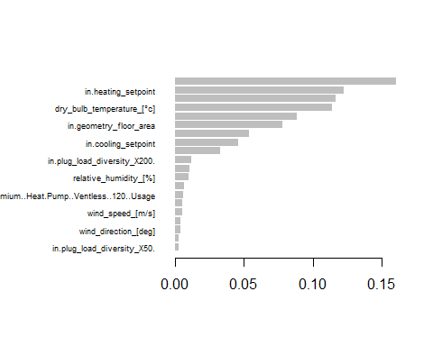

importance_matrix <- importance_matrix[order(importance_matrix$Importance, decreasing = TRUE), ]  
top_15_features <- importance_matrix$Feature[0:15]

##—————————————————————————————————————————————————————–>

## 5. Insight Generation

#### 1.Using Shapley to generate insights from the model.

#### 2.Shapley calculates the indivdial effect of the features towards total energy consumption.

#### 3.Analysing impact on Total energy consumption by studying Partial Dependance Plots and Feature Importance

#### 4.Instructions on reading the graph:

#### Understanding the y-axis:

#### The y-axis represents the predicted outcome (total energy consumption) of the model.

#### The 0 mark on the y-axis indicates average total energy consumption in the dataset

#### Understanding the x-axis:

#### The x-axis represents the values of the feature for which you are creating the Shapley PDP.

#### 5.Some notable insights:

#### a.Dry Bulb Temperature, House Size (sqft), Cooling and Heating Setpoint, Humidity are some of the top drivers of energy consumption.

#### b. Income : People who earn more than $30,000, consume the same amount of energy (50kWh in an 8 hour time span).

#### Below this income level, there is a steady decline in energy consumption as income reduces.

#### c.Temperature : After the weather outside crosses a temperature of 26 C, there is a spike in energy consumption across household.

#Create Shap object   
  
shp <- shapviz(xgb_model, X_pred = dtrain, X = X_train)  
colnames(shp) <- gsub("_", " ", colnames(shp))  
# Function to capitalize each word before and after a full stop  
capitalize_words <- function(x) {  
 words <- unlist(strsplit(x, "\\.", fixed = TRUE))  
 capitalized_words <- sapply(words, str_to_title)  
 return(paste(capitalized_words, collapse = "."))  
}  
# Capitalize each word in column names  
colnames(shp) <- sapply(colnames(shp), capitalize_words)  
  
  
# Display Shapley Feature Importance  
sv_importance(shp)

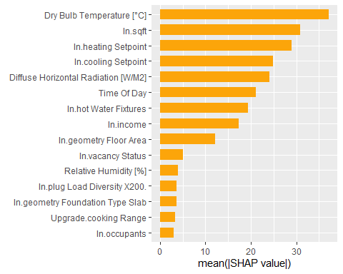

# Feature Importance with Direction of impact   
sv_importance(shp, kind = "beeswarm")

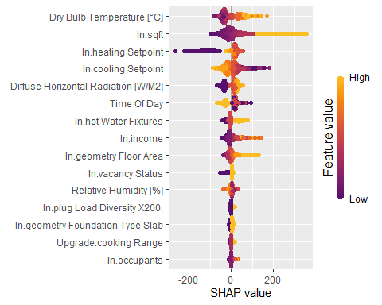

# Main effect of carat and its interactions  
for (col in top_15_features){  
 col <- gsub("_", " ", col)  
 col <- sapply(col, capitalize_words)  
 impact_of_column_on_energy <- sv_dependence(shp,v = col,color_var = col)  
 print(impact_of_column_on_energy)}

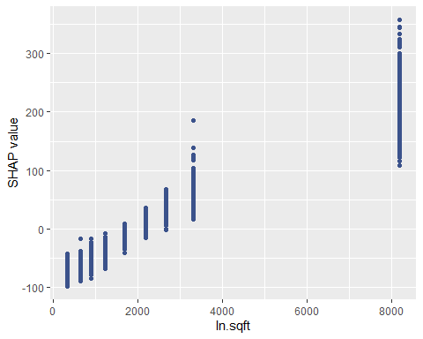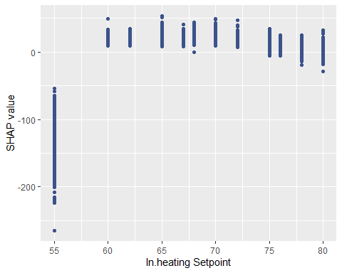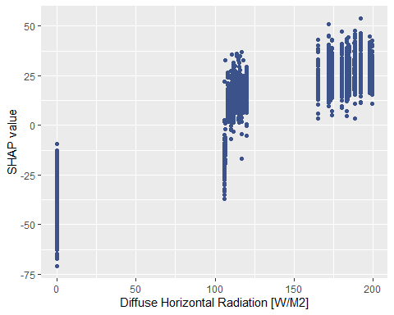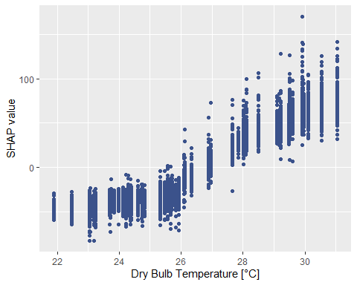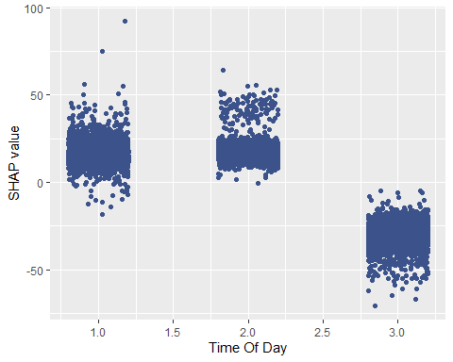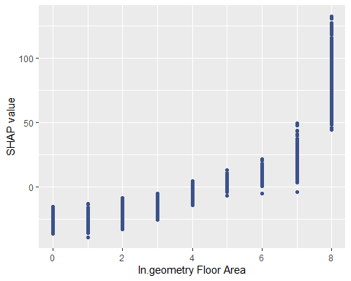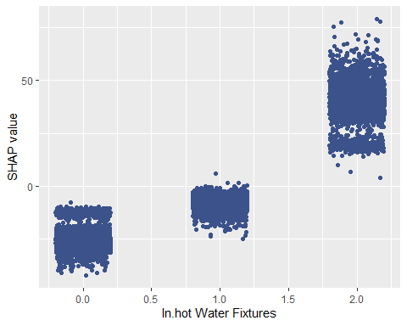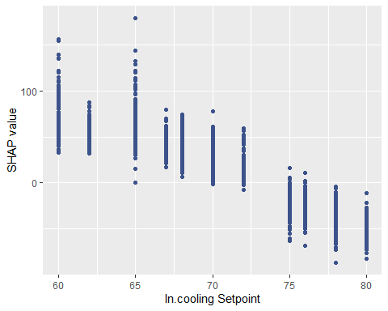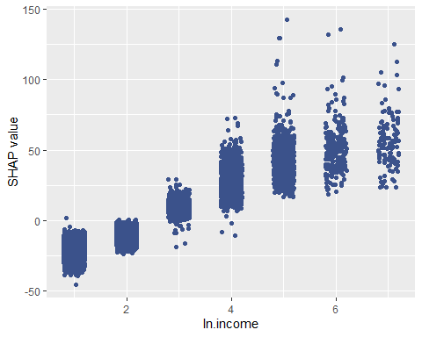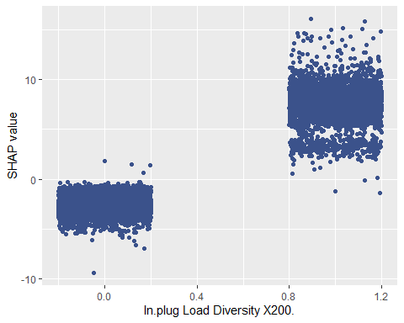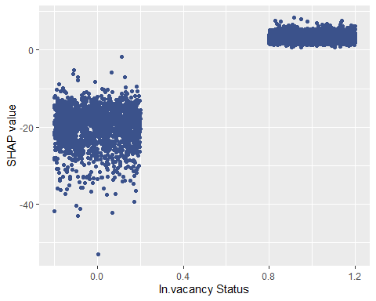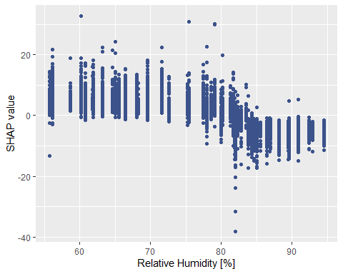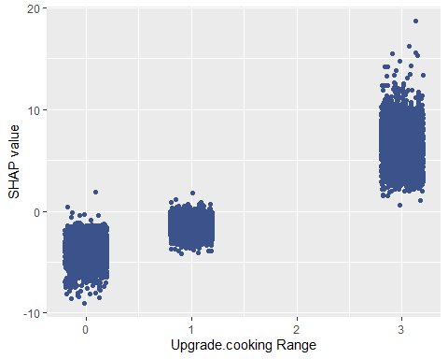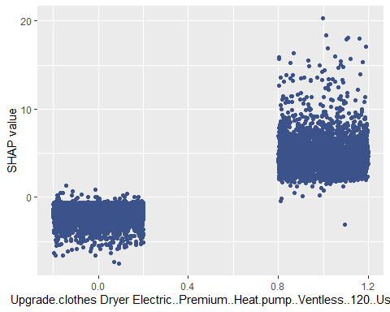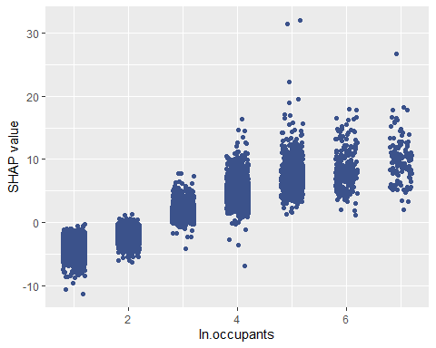

# Key to map the x axis of below graphs  
time_of_day_mapping <- c("morning"=1,"afternoon-evening"=2,"night"=3)  
in_vacancy_status_mapping <- c("Occupied"=1, "Vacant"=0 )  
in_geometry_floor_area_mapping <- c("0-499"=0 ,"500-749"=1,"750-999"=2,"1000-1499"=3,"1500-1999"=4,"2000-2499"=5,"2500-2999"=6,"3000-3999"=7,"4000+"=8)   
in_hot_water_fixtures_mapping <- c("100% Usage"=1, "50% Usage"=0, "200% Usage"=2)  
upgrade_cooking_range_mapping <- c("Electric, Induction, 100% Usage"=1, "Electric, Induction, 80% Usage"=0, "Electric, Induction, 120% Usage"=3)  
in_occupants_mapping <- c("1"=1 , "2"=2,"3"=3,"4"=4,"5"=5,"8"=8,"6"=6,"7"=7,"10+"=10,"9"=9)  
income_mapping <- c("<10000"=1, "10000-14999"=2, "15000-19999"=3, "20000-24999"=4, "25000-29999"=5, "30000-34999"=6, "35000-39999"=7, "40000-44999"=8, "45000-49999"=9, "50000-59999"=10, "60000-69999"=11, "70000-79999"=12, "80000-99999"=13, "100000-119999"=14, "120000-139999"=15, "140000-159999"=16, "160000-179999"=17, "180000-199999"=18, "200000+"=19)

##—————————————————————————————————————————————————————–>

## 6. Predictions - By increasing temp by 5

#### Add 5 degrees C to the Original Dataset, and Predict total Energy Consumed.

#### Calculate peak Future Energy Demand for Geographies,House size and Time of the Day.

#### Total energy predicted next july after increasing temparature by 5 degrees is: 5983238 kWh

#### and increase in total energy consumed next july is : 927594.8 kWh Percentage increase in Energy Consumed is : 18.34771 %

# Use prediction DF created in Linear Regression Section  
  
# ----------------->   
static_house_energy_weather_df_for_prediction2 <- static_house_energy_weather_df_for_prediction  
static_house_energy_weather_df_building_and_county <- static_house_energy_weather_df_for_prediction2[,c('bldg_id','in.county','time_of_day')]  
static_house_energy_weather_df_for_prediction2_processed_for_loaded_xgb_model <- static_house_energy_weather_df_for_prediction2 %>% select(-c( 'bldg_id','in.county','global_horizontal_radiation_[w/m2]',  
 'direct_normal_radiation_[w/m2]'))  
  
# Encode it using the label_recipe encoder created in previous steps (xgb cell)  
static_house_energy_weather_df4_prediction <- prep(label_recipe) %>% bake(new_data = static_house_energy_weather_df_for_prediction2_processed_for_loaded_xgb_model)

## New names:  
## New names:  
## New names:  
## New names:  
## • `in.cooling_setpoint_offset_period_Day.and.Night.Setup..1h` ->  
## `in.cooling_setpoint_offset_period_Day.and.Night.Setup..1h...116`  
## • `in.cooling_setpoint_offset_period_Day.and.Night.Setup..2h` ->  
## `in.cooling_setpoint_offset_period_Day.and.Night.Setup..2h...117`  
## • `in.cooling_setpoint_offset_period_Day.and.Night.Setup..3h` ->  
## `in.cooling_setpoint_offset_period_Day.and.Night.Setup..3h...118`  
## • `in.cooling_setpoint_offset_period_Day.and.Night.Setup..4h` ->  
## `in.cooling_setpoint_offset_period_Day.and.Night.Setup..4h...119`  
## • `in.cooling_setpoint_offset_period_Day.and.Night.Setup..5h` ->  
## `in.cooling_setpoint_offset_period_Day.and.Night.Setup..5h...120`  
## • `in.cooling_setpoint_offset_period_Day.and.Night.Setup..1h` ->  
## `in.cooling_setpoint_offset_period_Day.and.Night.Setup..1h...121`  
## • `in.cooling_setpoint_offset_period_Day.and.Night.Setup..2h` ->  
## `in.cooling_setpoint_offset_period_Day.and.Night.Setup..2h...122`  
## • `in.cooling_setpoint_offset_period_Day.and.Night.Setup..3h` ->  
## `in.cooling_setpoint_offset_period_Day.and.Night.Setup..3h...123`  
## • `in.cooling_setpoint_offset_period_Day.and.Night.Setup..4h` ->  
## `in.cooling_setpoint_offset_period_Day.and.Night.Setup..4h...124`  
## • `in.cooling_setpoint_offset_period_Day.and.Night.Setup..5h` ->  
## `in.cooling_setpoint_offset_period_Day.and.Night.Setup..5h...125`  
## • `in.cooling_setpoint_offset_period_Day.Setup..1h` ->  
## `in.cooling_setpoint_offset_period_Day.Setup..1h...127`  
## • `in.cooling_setpoint_offset_period_Day.Setup..2h` ->  
## `in.cooling_setpoint_offset_period_Day.Setup..2h...128`  
## • `in.cooling_setpoint_offset_period_Day.Setup..3h` ->  
## `in.cooling_setpoint_offset_period_Day.Setup..3h...129`  
## • `in.cooling_setpoint_offset_period_Day.Setup..4h` ->  
## `in.cooling_setpoint_offset_period_Day.Setup..4h...130`  
## • `in.cooling_setpoint_offset_period_Day.Setup..5h` ->  
## `in.cooling_setpoint_offset_period_Day.Setup..5h...131`  
## • `in.cooling_setpoint_offset_period_Day.Setup..1h` ->  
## `in.cooling_setpoint_offset_period_Day.Setup..1h...132`  
## • `in.cooling_setpoint_offset_period_Day.Setup..2h` ->  
## `in.cooling_setpoint_offset_period_Day.Setup..2h...133`  
## • `in.cooling_setpoint_offset_period_Day.Setup..3h` ->  
## `in.cooling_setpoint_offset_period_Day.Setup..3h...134`  
## • `in.cooling_setpoint_offset_period_Day.Setup..4h` ->  
## `in.cooling_setpoint_offset_period_Day.Setup..4h...135`  
## • `in.cooling_setpoint_offset_period_Day.Setup..5h` ->  
## `in.cooling_setpoint_offset_period_Day.Setup..5h...136`  
## • `in.cooling_setpoint_offset_period_Day.Setup.and.Night.Setback..1h` ->  
## `in.cooling_setpoint_offset_period_Day.Setup.and.Night.Setback..1h...138`  
## • `in.cooling_setpoint_offset_period_Day.Setup.and.Night.Setback..2h` ->  
## `in.cooling_setpoint_offset_period_Day.Setup.and.Night.Setback..2h...139`  
## • `in.cooling_setpoint_offset_period_Day.Setup.and.Night.Setback..3h` ->  
## `in.cooling_setpoint_offset_period_Day.Setup.and.Night.Setback..3h...140`  
## • `in.cooling_setpoint_offset_period_Day.Setup.and.Night.Setback..4h` ->  
## `in.cooling_setpoint_offset_period_Day.Setup.and.Night.Setback..4h...141`  
## • `in.cooling_setpoint_offset_period_Day.Setup.and.Night.Setback..5h` ->  
## `in.cooling_setpoint_offset_period_Day.Setup.and.Night.Setback..5h...142`  
## • `in.cooling_setpoint_offset_period_Day.Setup.and.Night.Setback..1h` ->  
## `in.cooling_setpoint_offset_period_Day.Setup.and.Night.Setback..1h...143`  
## • `in.cooling_setpoint_offset_period_Day.Setup.and.Night.Setback..2h` ->  
## `in.cooling_setpoint_offset_period_Day.Setup.and.Night.Setback..2h...144`  
## • `in.cooling_setpoint_offset_period_Day.Setup.and.Night.Setback..3h` ->  
## `in.cooling_setpoint_offset_period_Day.Setup.and.Night.Setback..3h...145`  
## • `in.cooling_setpoint_offset_period_Day.Setup.and.Night.Setback..4h` ->  
## `in.cooling_setpoint_offset_period_Day.Setup.and.Night.Setback..4h...146`  
## • `in.cooling_setpoint_offset_period_Day.Setup.and.Night.Setback..5h` ->  
## `in.cooling_setpoint_offset_period_Day.Setup.and.Night.Setback..5h...147`  
## • `in.cooling_setpoint_offset_period_Night.Setback..1h` ->  
## `in.cooling_setpoint_offset_period_Night.Setback..1h...149`  
## • `in.cooling_setpoint_offset_period_Night.Setback..2h` ->  
## `in.cooling_setpoint_offset_period_Night.Setback..2h...150`  
## • `in.cooling_setpoint_offset_period_Night.Setback..3h` ->  
## `in.cooling_setpoint_offset_period_Night.Setback..3h...151`  
## • `in.cooling_setpoint_offset_period_Night.Setback..4h` ->  
## `in.cooling_setpoint_offset_period_Night.Setback..4h...152`  
## • `in.cooling_setpoint_offset_period_Night.Setback..5h` ->  
## `in.cooling_setpoint_offset_period_Night.Setback..5h...153`  
## • `in.cooling_setpoint_offset_period_Night.Setback..1h` ->  
## `in.cooling_setpoint_offset_period_Night.Setback..1h...154`  
## • `in.cooling_setpoint_offset_period_Night.Setback..2h` ->  
## `in.cooling_setpoint_offset_period_Night.Setback..2h...155`  
## • `in.cooling_setpoint_offset_period_Night.Setback..3h` ->  
## `in.cooling_setpoint_offset_period_Night.Setback..3h...156`  
## • `in.cooling_setpoint_offset_period_Night.Setback..4h` ->  
## `in.cooling_setpoint_offset_period_Night.Setback..4h...157`  
## • `in.cooling_setpoint_offset_period_Night.Setback..5h` ->  
## `in.cooling_setpoint_offset_period_Night.Setback..5h...158`  
## • `in.cooling_setpoint_offset_period_Night.Setup..1h` ->  
## `in.cooling_setpoint_offset_period_Night.Setup..1h...160`  
## • `in.cooling_setpoint_offset_period_Night.Setup..2h` ->  
## `in.cooling_setpoint_offset_period_Night.Setup..2h...161`  
## • `in.cooling_setpoint_offset_period_Night.Setup..3h` ->  
## `in.cooling_setpoint_offset_period_Night.Setup..3h...162`  
## • `in.cooling_setpoint_offset_period_Night.Setup..4h` ->  
## `in.cooling_setpoint_offset_period_Night.Setup..4h...163`  
## • `in.cooling_setpoint_offset_period_Night.Setup..5h` ->  
## `in.cooling_setpoint_offset_period_Night.Setup..5h...164`  
## • `in.cooling_setpoint_offset_period_Night.Setup..1h` ->  
## `in.cooling_setpoint_offset_period_Night.Setup..1h...165`  
## • `in.cooling_setpoint_offset_period_Night.Setup..2h` ->  
## `in.cooling_setpoint_offset_period_Night.Setup..2h...166`  
## • `in.cooling_setpoint_offset_period_Night.Setup..3h` ->  
## `in.cooling_setpoint_offset_period_Night.Setup..3h...167`  
## • `in.cooling_setpoint_offset_period_Night.Setup..4h` ->  
## `in.cooling_setpoint_offset_period_Night.Setup..4h...168`  
## • `in.cooling_setpoint_offset_period_Night.Setup..5h` ->  
## `in.cooling_setpoint_offset_period_Night.Setup..5h...169`

#-----------------> Increase Temp by 5  
static_house_energy_weather_df4_prediction$`dry_bulb_temperature_[°c]` <- static_house_energy_weather_df4_prediction$`dry_bulb_temperature_[°c]`+5  
  
# Increase Temp by 5-> Create dataset to be converted to a martix for xgb prediction  
static_house_energy_weather_df4_prediction_independant <- static_house_energy_weather_df4_prediction %>% select (-c('total_energy_consumption'))  
static_house_energy_weather_df4_prediction_dependant <- static_house_energy_weather_df4_prediction$total_energy_consumption  
  
  
#Create matrix which is a pre-requisite to XGboost prediction  
static_house_energy_weather_df4_matrix <- xgb.DMatrix(data = as.matrix(static_house_energy_weather_df4_prediction_independant ), label = static_house_energy_weather_df4_prediction_dependant)  
predictions_plus_5_temp <- predict(xgb_model, newdata = static_house_energy_weather_df4_matrix)  
  
#Add prediction columns to original DF  
static_house_energy_weather_df_for_prediction2$total_energy_consumption_prediction_after_increasing_temp <- predictions_plus_5_temp  
  
#Predicted - Current = Increase in energy   
static_house_energy_weather_df_for_prediction2$change_in_total_energy <- static_house_energy_weather_df_for_prediction2$total_energy_consumption_prediction_after_increasing_temp - static_house_energy_weather_df_for_prediction2$total_energy_consumption   
  
#TotalEnergy  
total_energy_next_july_after_increasing_temp <- sum(static_house_energy_weather_df_for_prediction2$total_energy_consumption_prediction_after_increasing_temp)  
  
total_change_in_energy_this_july_to_last_july <- sum(static_house_energy_weather_df_for_prediction2$change_in_total_energy)  
  
percentage_increase_in_energy_consumed <- total_change_in_energy_this_july_to_last_july*100/sum(static_house_energy_weather_df_for_prediction2$total_energy_consumption)  
  
cat("Total energy predicted next july after increasing temparature by 5 degrees is: ",total_energy_next_july_after_increasing_temp," kWh", " and increase in total energy consumed next july is :",total_change_in_energy_this_july_to_last_july," kWh")

## Total energy predicted next july after increasing temparature by 5 degrees is: 5983238 kWh and increase in total energy consumed next july is : 927594.8 kWh

cat(" Percentage increase in Energy Consumed is :",percentage_increase_in_energy_consumed, " %")

## Percentage increase in Energy Consumed is : 18.34771 %

# #calculate peak energy demand for geographies and regions  
options(dplyr.summarise.inform = FALSE)  
time_of_day_reverse_mapping <- c("1"="morning","2"="afternoon-evening","3"="night")  
  
geography_energy_demand_df <- static_house_energy_weather_df_for_prediction2 %>%   
 group_by(in.county) %>%   
 dplyr::summarise(total_energy_prediction_next_year_per_hour = sum(total_energy_consumption_prediction_after_increasing_temp)/8, total_energy__consumption_this_year_per_hour = sum(total_energy_consumption)/8)  
  
geography_energy_demand_df$percentage_change_in_energy_consumption_per_hour <- (geography_energy_demand_df$total_energy_prediction_next_year_per_hour-geography_energy_demand_df$total_energy__consumption_this_year_per_hour)*100/geography_energy_demand_df$total_energy__consumption_this_year_per_hour   
  
head(geography_energy_demand_df)

## # A tibble: 6 × 4  
## in.county total_energy_predict…¹ total_energy__consum…² percentage_change_in…³  
## <chr> <dbl> <dbl> <dbl>  
## 1 G4500010 3769. 3014. 25.0  
## 2 G4500030 26575. 22183. 19.8  
## 3 G4500050 1331. 1100. 21.0  
## 4 G4500070 33435. 28071. 19.1  
## 5 G4500090 2636. 2278. 15.7  
## 6 G4500110 2550. 2155. 18.3  
## # ℹ abbreviated names: ¹​total_energy_prediction_next_year_per_hour,  
## # ²​total_energy__consumption_this_year_per_hour,  
## # ³​percentage_change_in_energy_consumption_per_hour

## Calculating peak energy demand for sqft  
  
sqft_wise_energy_demand_df <- static_house_energy_weather_df_for_prediction2 %>%   
 group_by(in.sqft) %>%   
 dplyr::summarise(total_energy_prediction_next_year_per_hour = sum(total_energy_consumption_prediction_after_increasing_temp)/8, total_energy__consumption_this_year_per_hour = sum(total_energy_consumption)/8)  
sqft_wise_energy_demand_df$percentage_change_in_energy_consumption <- (sqft_wise_energy_demand_df$total_energy_prediction_next_year_per_hour-sqft_wise_energy_demand_df$total_energy__consumption_this_year_per_hour)*100/sqft_wise_energy_demand_df$total_energy__consumption_this_year_per_hour  
  
head(geography_energy_demand_df)

## # A tibble: 6 × 4  
## in.county total_energy_predict…¹ total_energy__consum…² percentage_change_in…³  
## <chr> <dbl> <dbl> <dbl>  
## 1 G4500010 3769. 3014. 25.0  
## 2 G4500030 26575. 22183. 19.8  
## 3 G4500050 1331. 1100. 21.0  
## 4 G4500070 33435. 28071. 19.1  
## 5 G4500090 2636. 2278. 15.7  
## 6 G4500110 2550. 2155. 18.3  
## # ℹ abbreviated names: ¹​total_energy_prediction_next_year_per_hour,  
## # ²​total_energy__consumption_this_year_per_hour,  
## # ³​percentage_change_in_energy_consumption_per_hour

## Calculating peak energy demand for time of the day  
time_of_day_wise_energy_demand_df <- static_house_energy_weather_df_for_prediction2 %>%   
 group_by(time_of_day) %>%   
 dplyr::summarise(total_energy_prediction_next_year_per_hour = sum(total_energy_consumption_prediction_after_increasing_temp)/8, total_energy__consumption_this_year_per_hour = sum(total_energy_consumption)/8)  
time_of_day_wise_energy_demand_df$time_of_day <- as.character(time_of_day_reverse_mapping[time_of_day_wise_energy_demand_df$time_of_day])  
  
time_of_day_wise_energy_demand_df$percentage_change_in_energy_consumption_per_hour <- (time_of_day_wise_energy_demand_df$total_energy_prediction_next_year_per_hour-time_of_day_wise_energy_demand_df$total_energy__consumption_this_year_per_hour)*100/time_of_day_wise_energy_demand_df$total_energy__consumption_this_year_per_hour  
  
head(time_of_day_wise_energy_demand_df)

## # A tibble: 3 × 4  
## time_of_day total_energy_prediction_next_year_p…¹ total_energy__consum…²  
## <chr> <dbl> <dbl>  
## 1 morning 264819. 215282.  
## 2 afternoon-evening 291670. 278974.  
## 3 night 191416. 137700.  
## # ℹ abbreviated names: ¹​total_energy_prediction_next_year_per_hour,  
## # ²​total_energy__consumption_this_year_per_hour  
## # ℹ 1 more variable: percentage_change_in_energy_consumption_per_hour <dbl>

# write.csv(sqft_wise_energy_demand_df, file = "C:/Users/Himanshu/OneDrive/Desktop/Syracuse Sem 1/IST-687 Intro to DS Lab/Final Project/size_of_house_surge.csv",row.names = FALSE)